Contents

Limits, Permissions, Conditions 2

Limits 2

Permissions 2

Conditions 2

Create sharebox group 3

Add a new member 4

Failure 4

Success 5

Delete a member 6

Deleting 6

Feedback for deleted member 7

Leave group 8

View/Edit Members 9

Scripts and Assets interface 10

# Limits, Permissions, Conditions

### Limits

|  |  |
| --- | --- |
| Limit | Value |
| Max number of group members | 5 |

### Permissions

|  |  |  |
| --- | --- | --- |
| Permission | Value | Details |
| Add member | Creator only |  |
| Delete member | Creator only |  |
| Leave group | Everybody | If creator leaves the group, destroy everything |
| View members | Everybody |  |

### Conditions

|  |  |
| --- | --- |
| Activity | Condition |
| Accept invite | Invitee must be online |
| Remain in a group | None at the moment. Group members can go offline and still remain in their group. |

# Create sharebox group

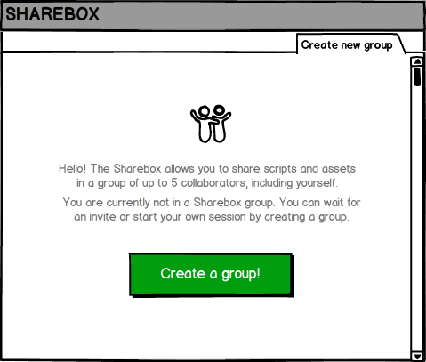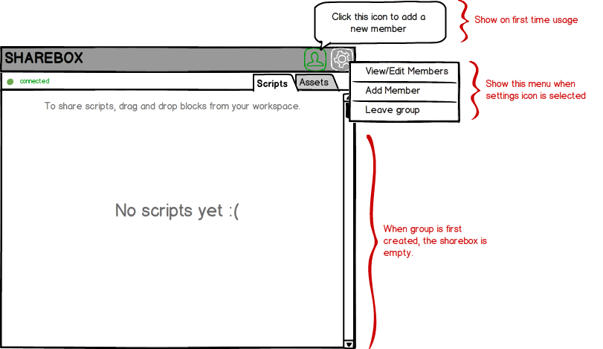

# Add a new member

### Failure

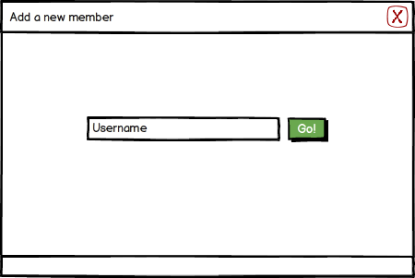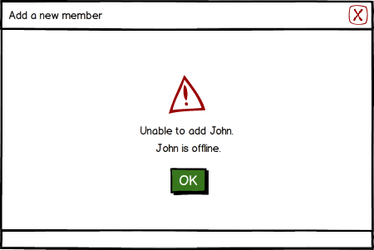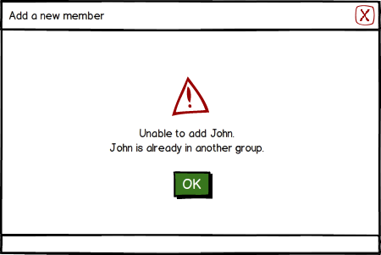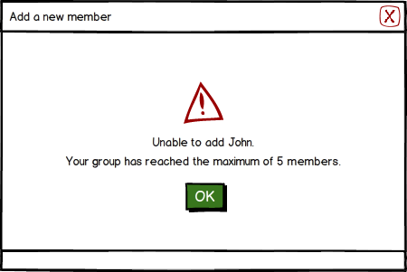

### Success



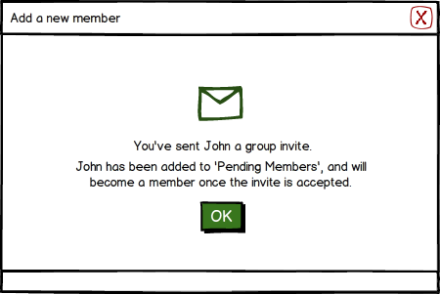

# Delete a member

### Deleting

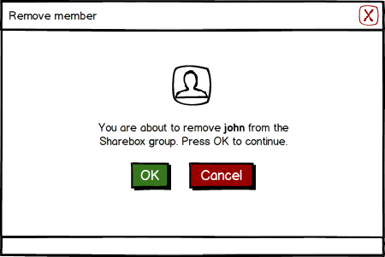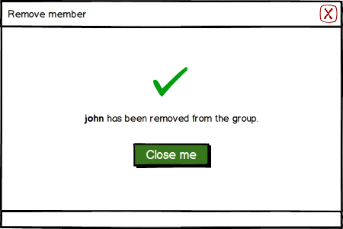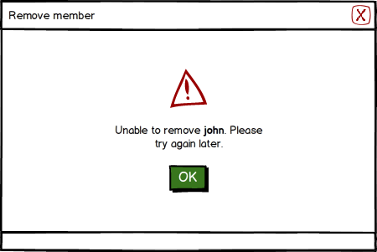

### Feedback for deleted member

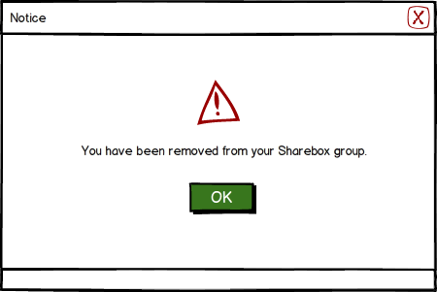

# Leave group

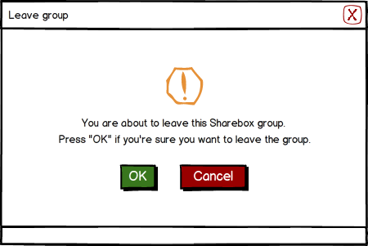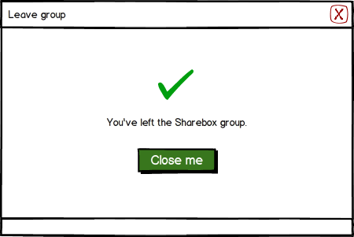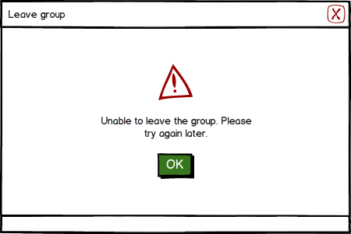

# View/Edit Members

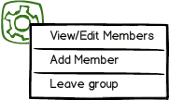

Delete member (creator only)

(

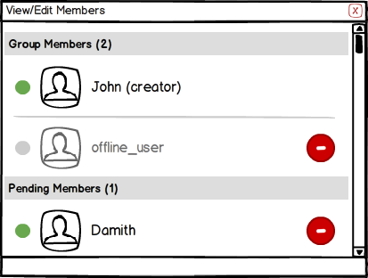

# Scripts and Assets interface

